Nalongsone Danddank Student ID : 14958950 StarID: jf3893pd

Email: [nalongsone.danddank@my.metrostate.edu](mailto:nalongsone.danddank@my.metrostate.edu)\

**ICS 432 - 01 — Distributed and Cloud Computing Fall 2021**

**Lab #9 :** Running a map-reduce job on a Hadoop cluster

Exercise 1: Running map-reduce jobs on the cloud

**Lab report screen-shot #1:**

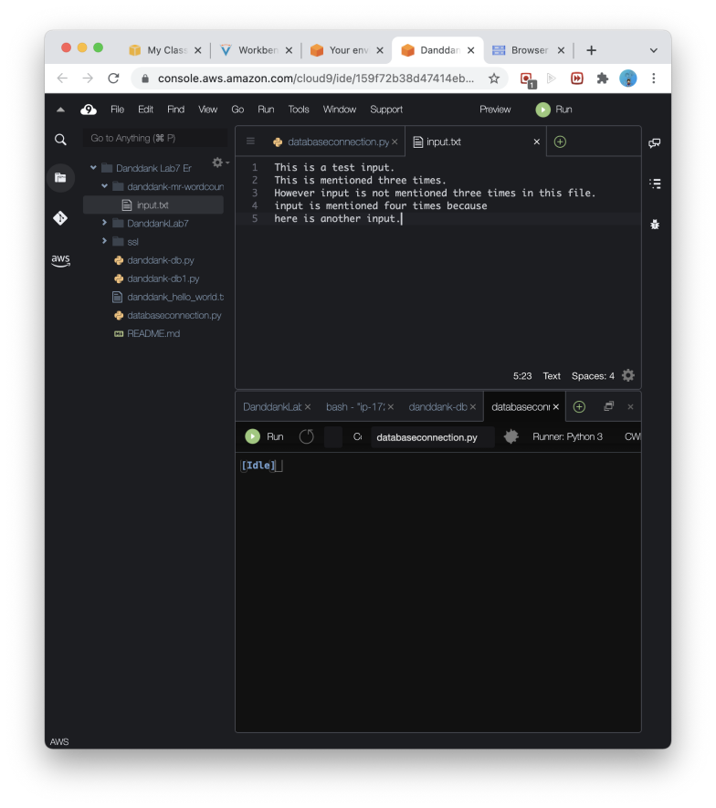

**Lab report screen-shot #2:**

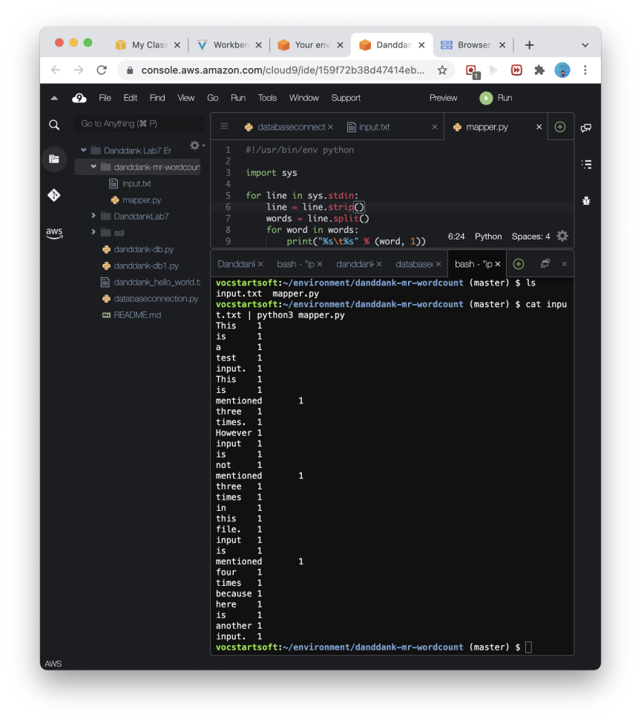

**Lab report screen-shot #3:**

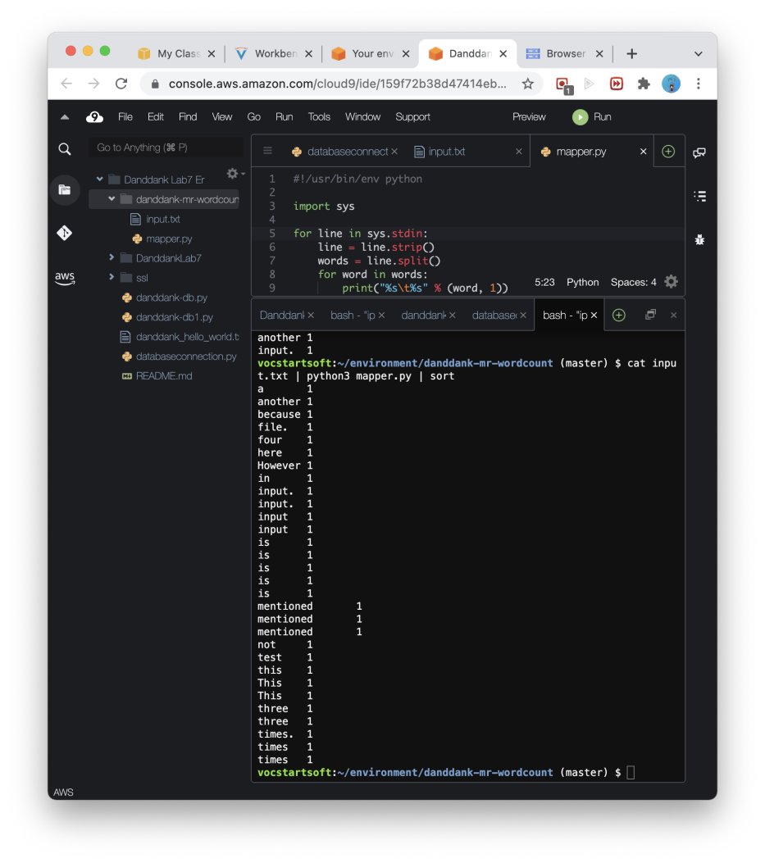

**Lab report screen-shot #4:**

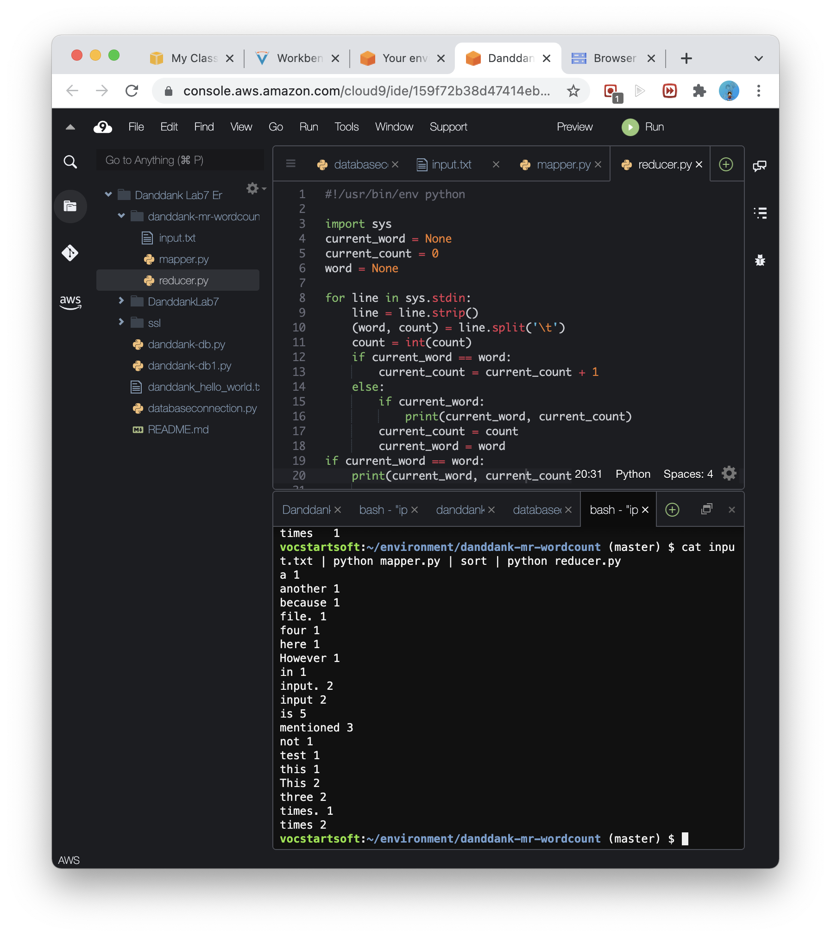

**Lab report screen-shot #5:**

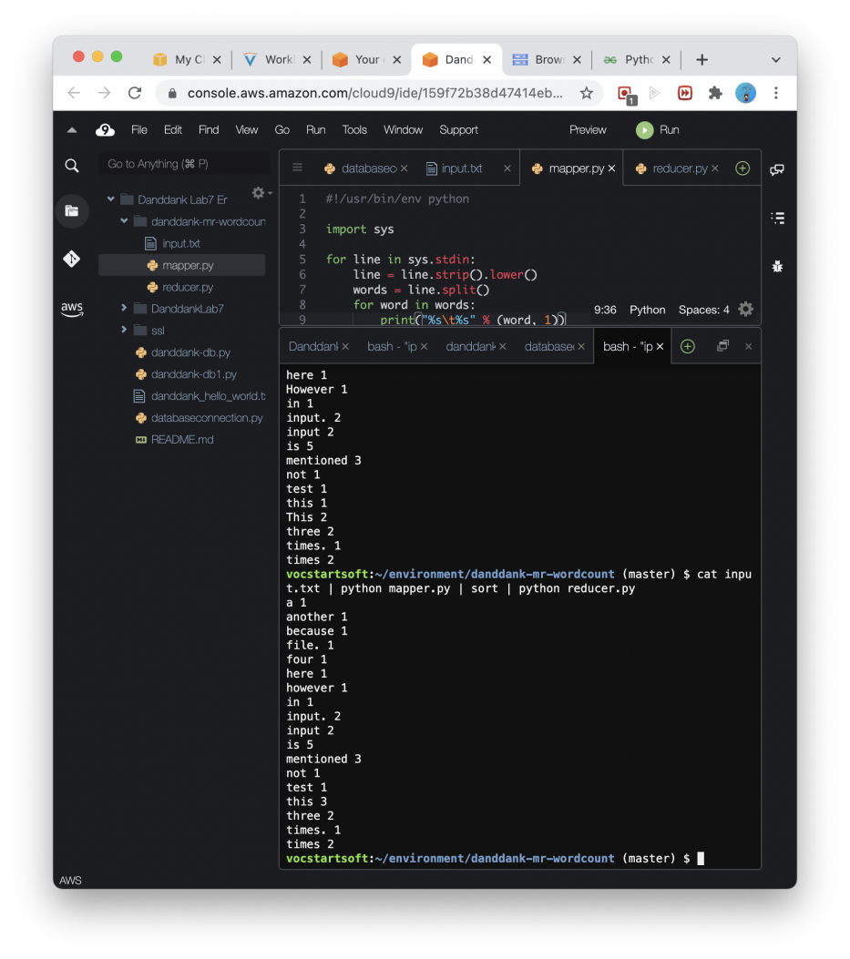

**Lab report screen-shot #6:**

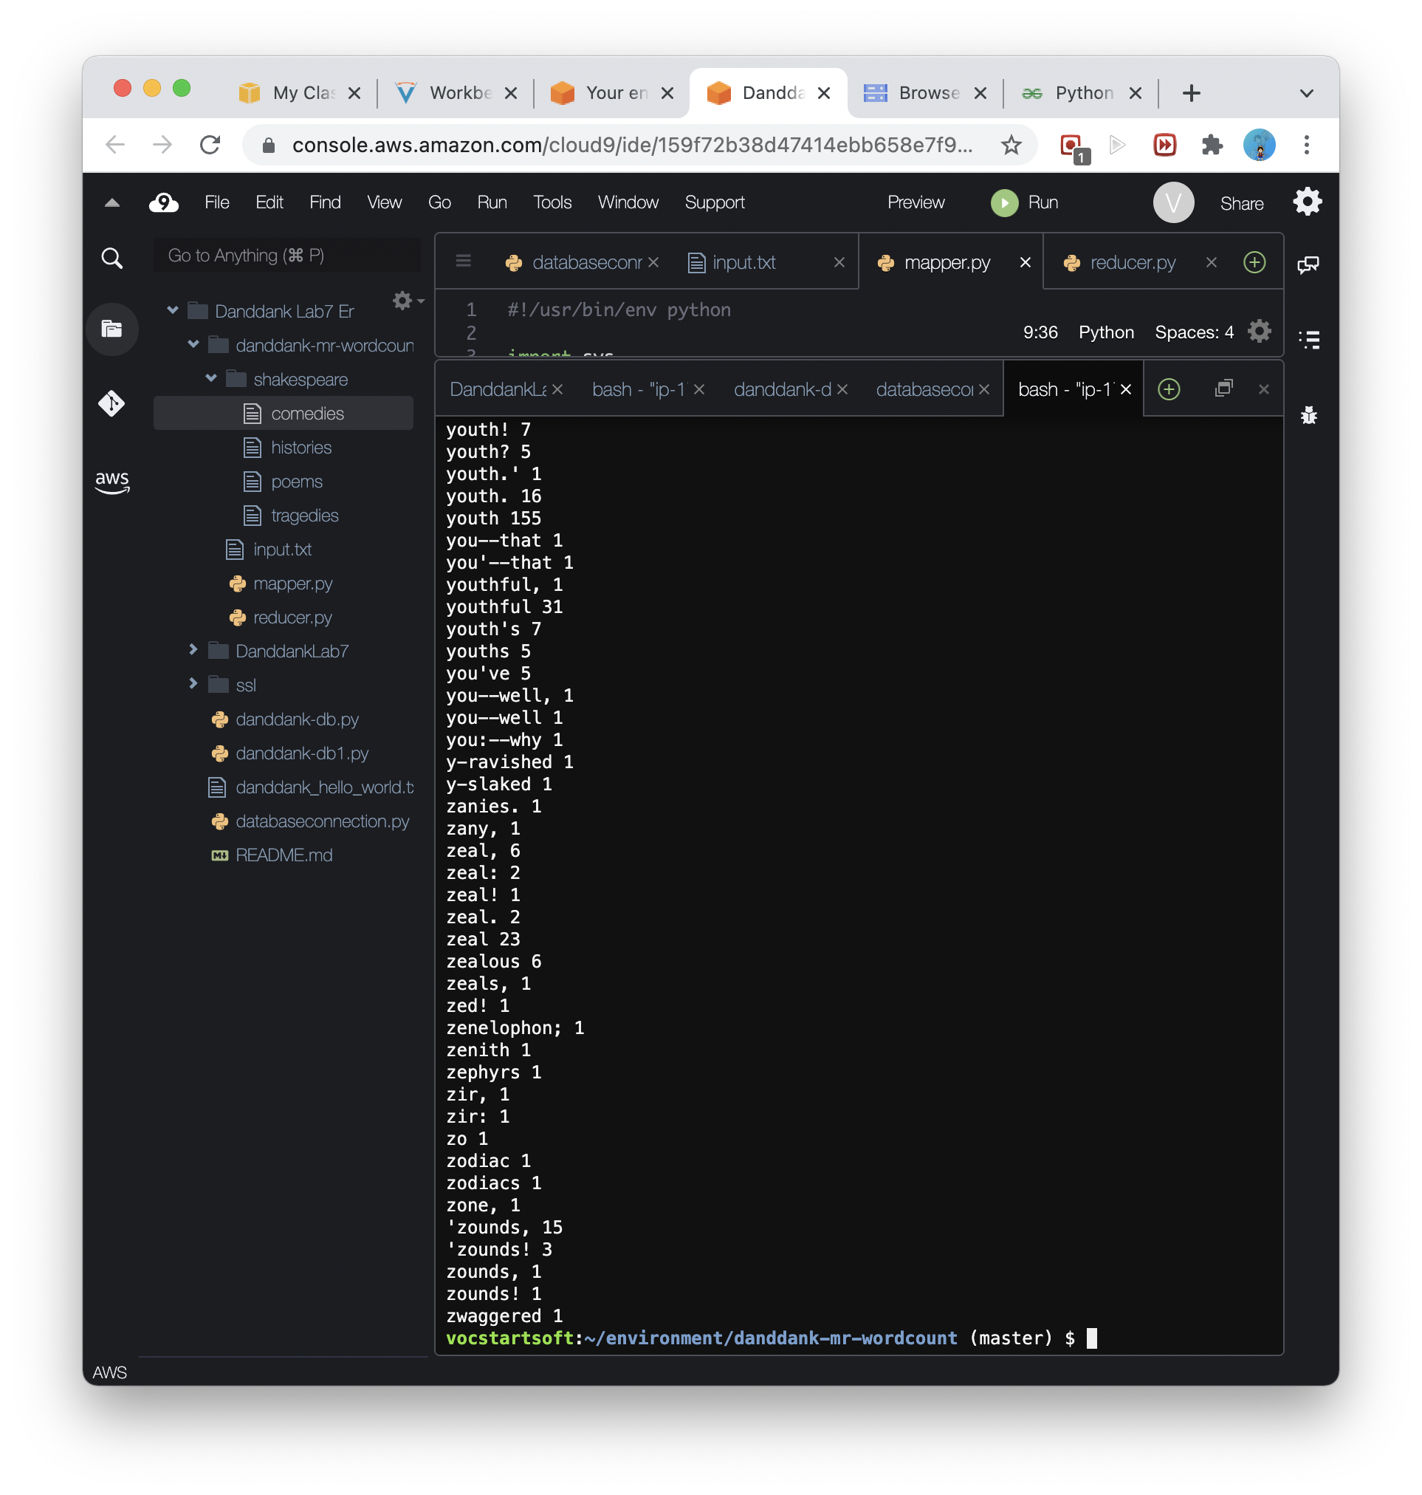

**Lab report screen-shot #7:**

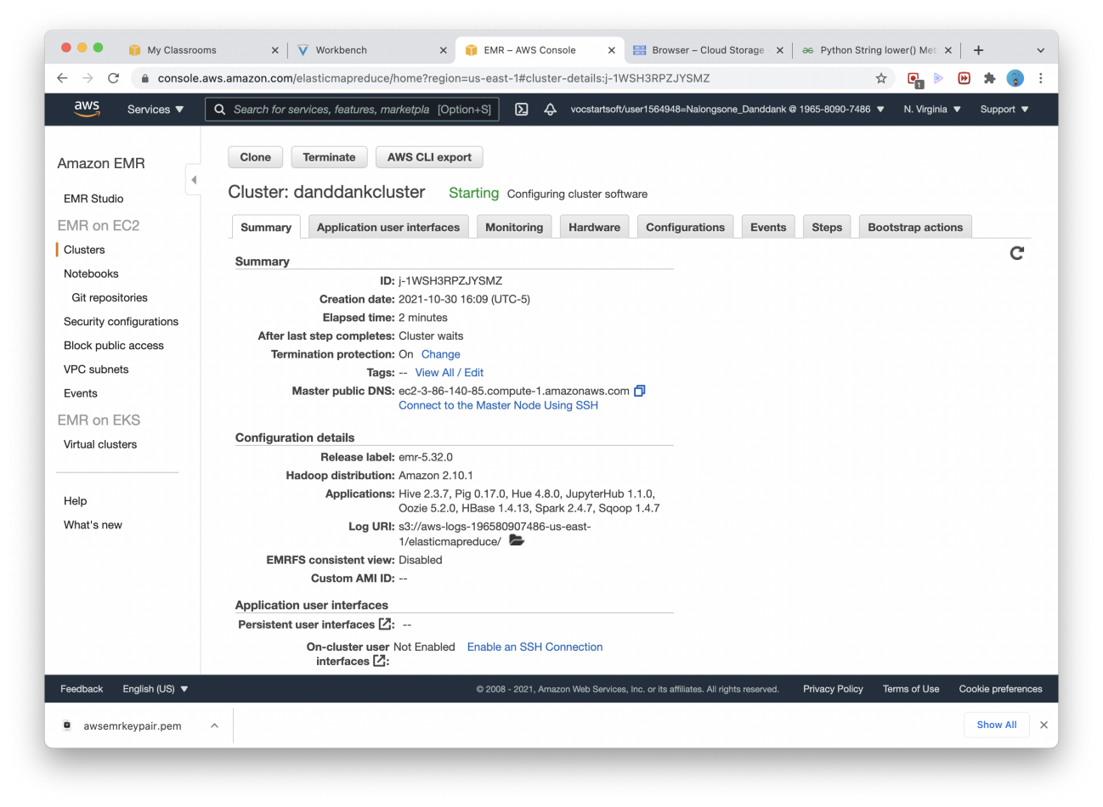

**Lab report screen-shot #8:**

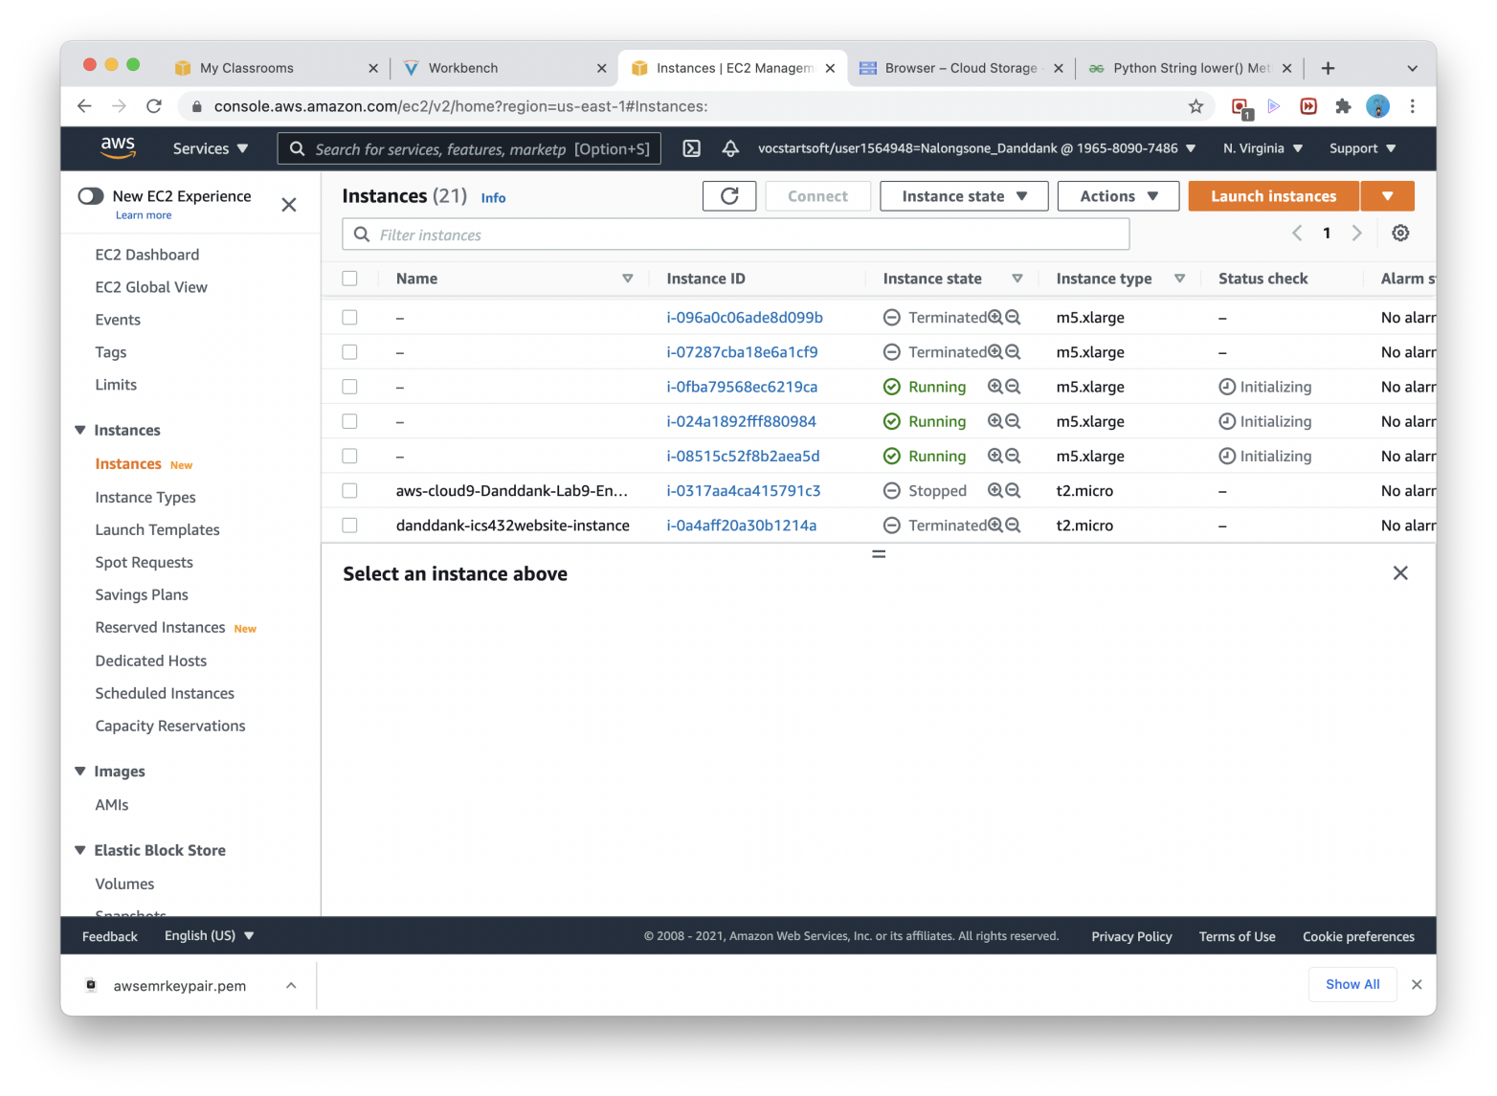

**Lab report screen-shot #9:**

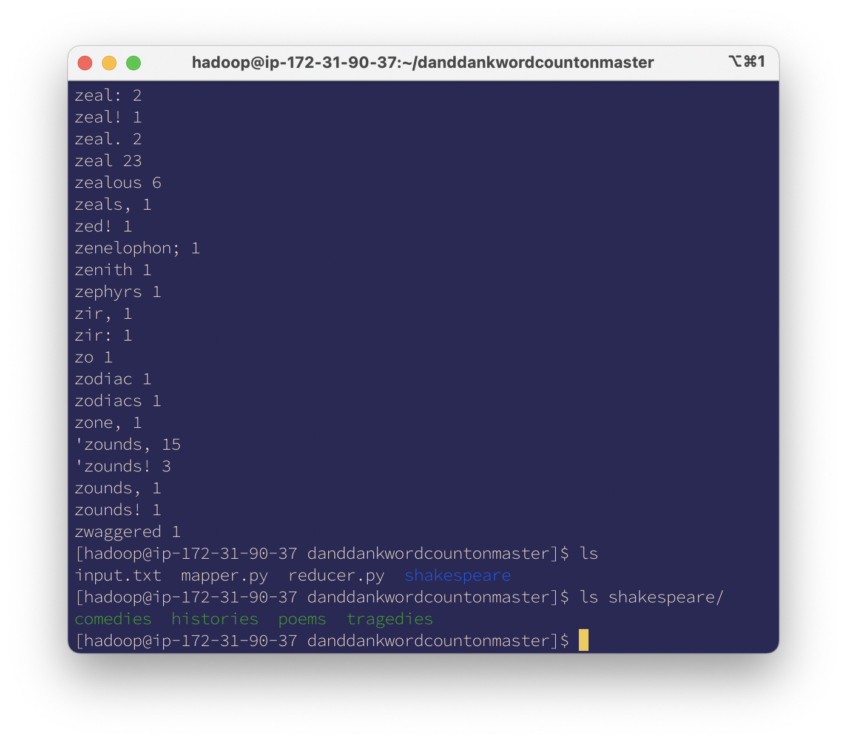

**Lab report screen-shot #10:**

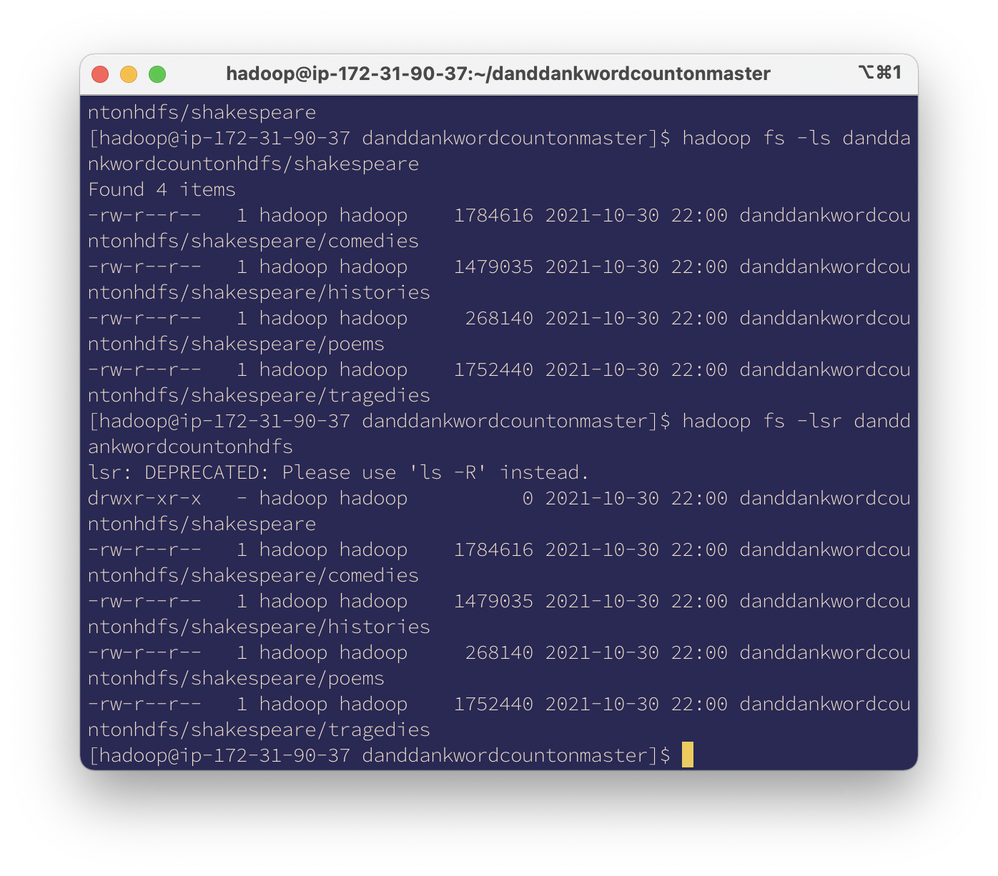

**Lab report screen-shot #11:**

1. **hadoop fs -mkdir danddankFolder**
2. **hadoop fs -put input.txt danddankFolder/input.txt**
3. **hadoop fs -ls danddankFolder**
4. **hadoop fs -cat danddankFolder/input.txt**
5. **hadoop fs -mv danddankFolder/input.txt danddankFolder/newInput.txt**
6. **hadoop fs -mkdir nalongsoneFolder**

**Had oop fs -mv danddankFolder/newInput.txt nalongsoneFolder/newInput.txt**

**g. hadoop fs -du nalongsoneFolder/newInput.txt**

**h. hadoop fs -get nalongsoneFolder/newInput.txt newInput.txt**

**i. hadoop fs -rm nalongsoneFolder/newInput.txt**

**j. hadoop fs -rm -r nalongsoneFolder**

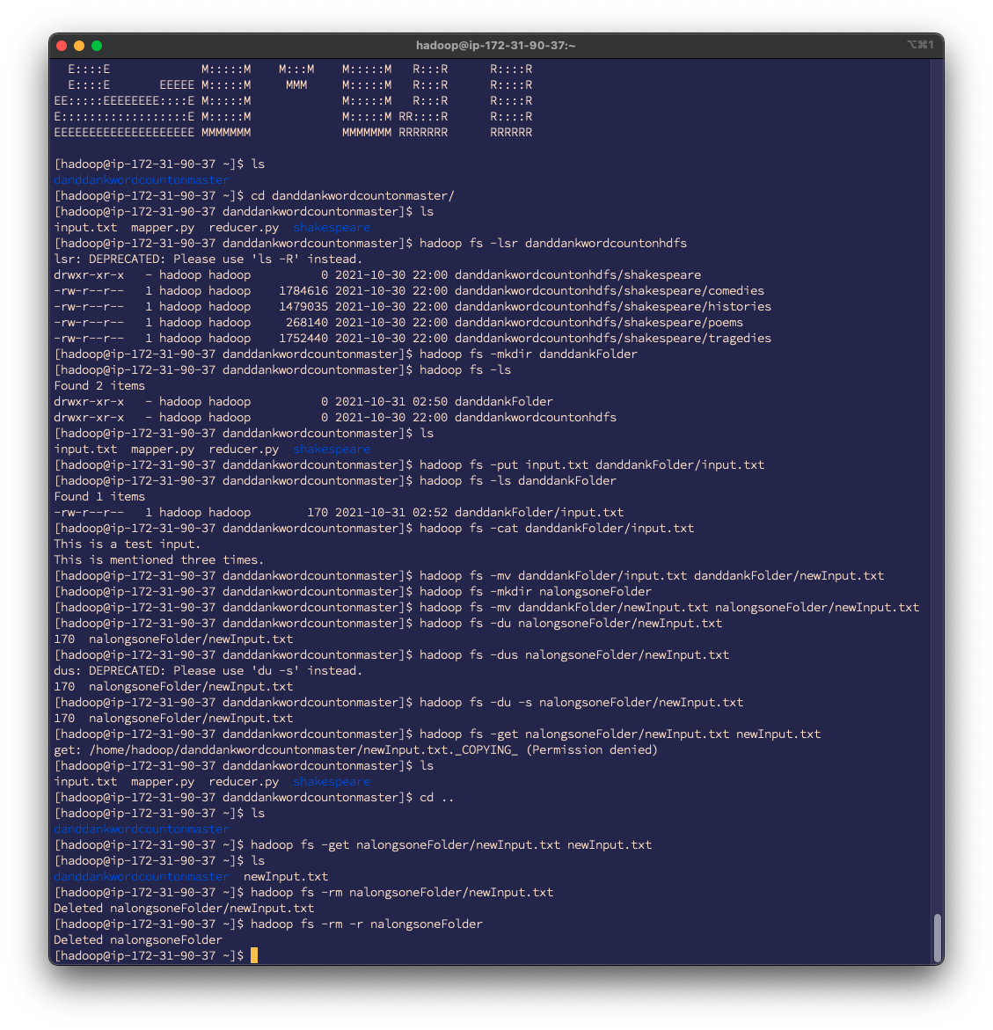

**Lab report screen-shot #12:**

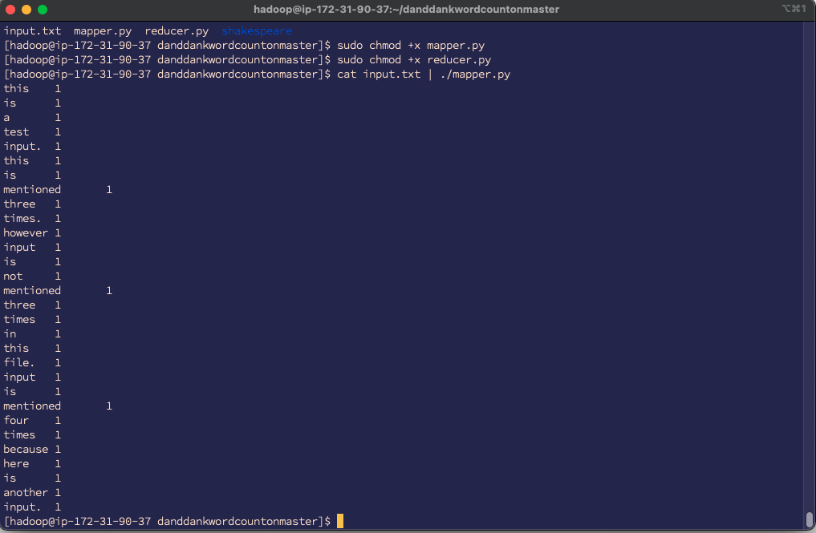

**Lab report screen-shot #13:**

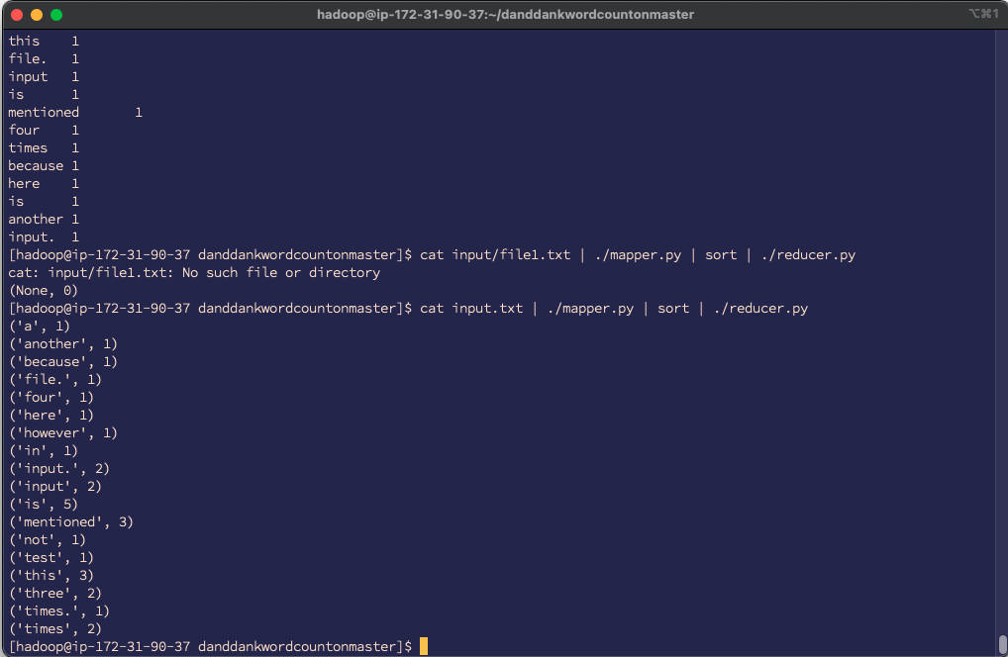

**Lab report screen-shot #14:**

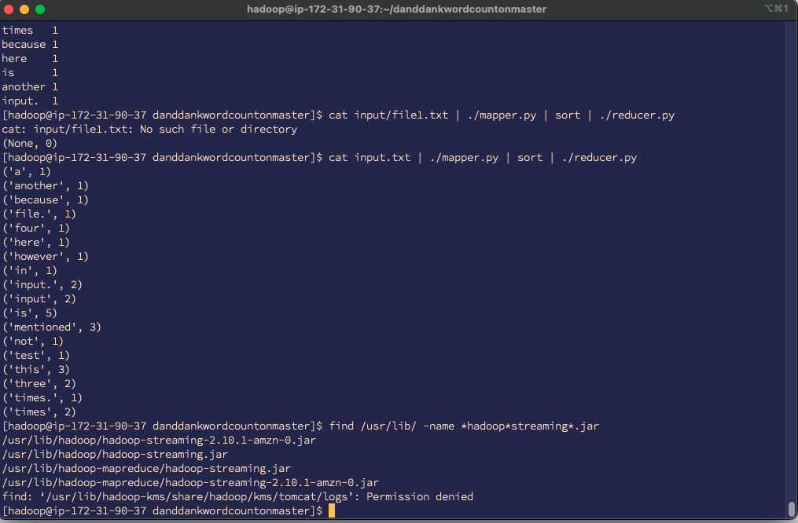

**Lab report screen-shot #15:**

|  |  |
| --- | --- |
| **How many data-local map tasks were executed?** | **4** |
| How many rack-local map tasks were executed? | **6** |
| How many reduce tasks? | **3** |
| Total time spent by all maps? | **4296096** |
| Total time spent by all reduce tasks? | **9677** |
| How many map-input records? | **173126** |
| How many map output records? | **939236** |
| How many reduce input groups? | **62933** |

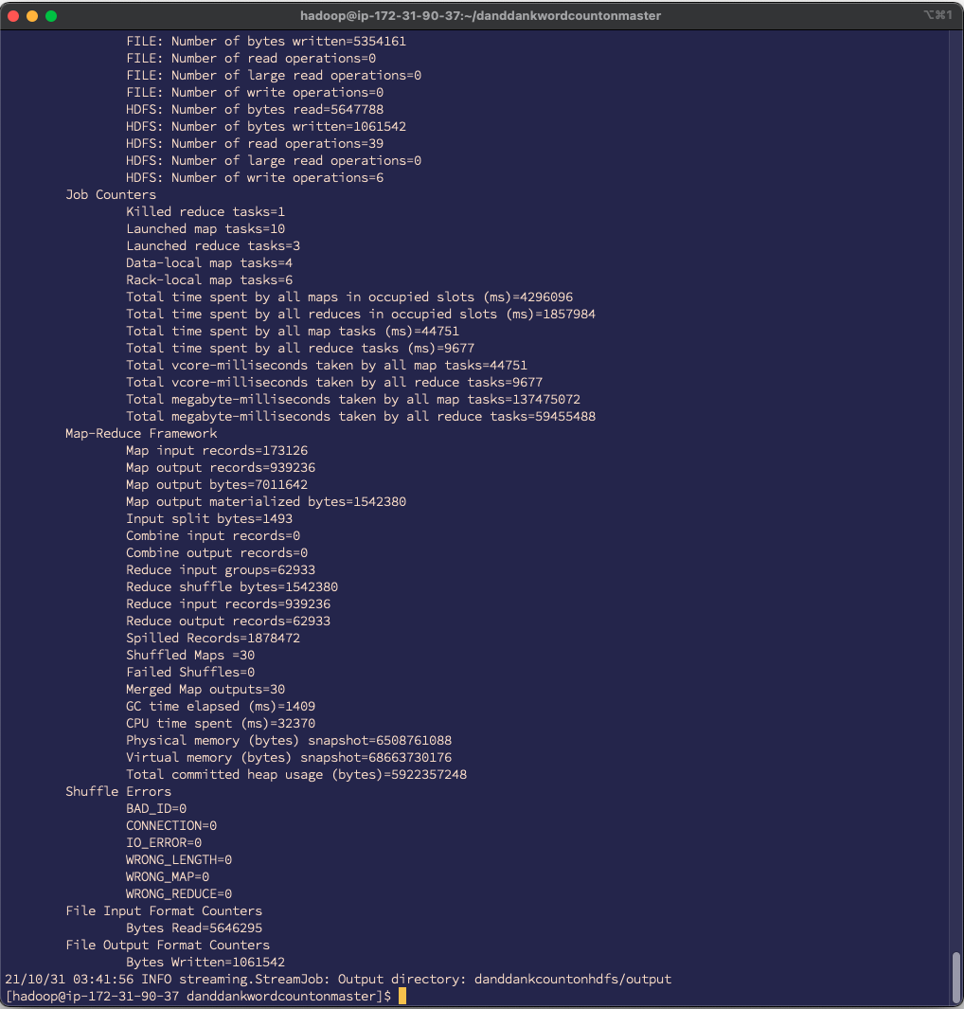

**Lab report screen-shot #16:**

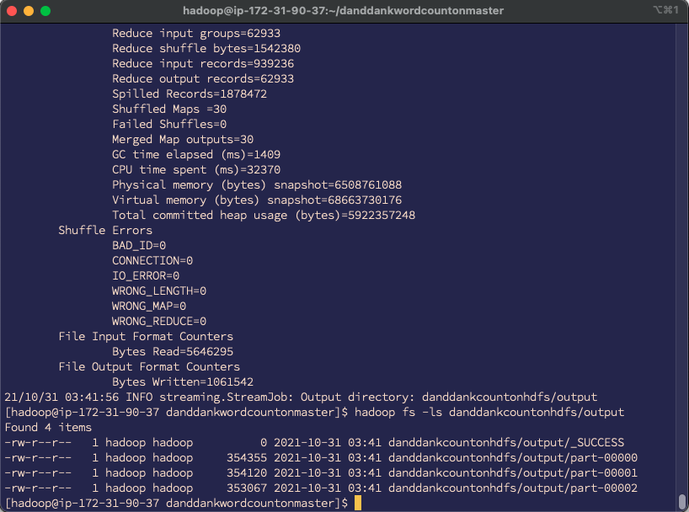

**Lab report screen-shot #17:**

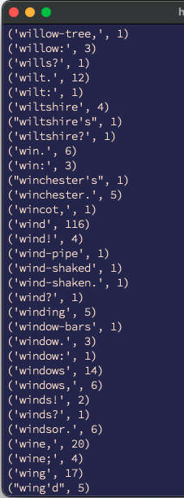 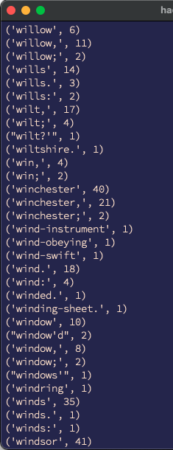 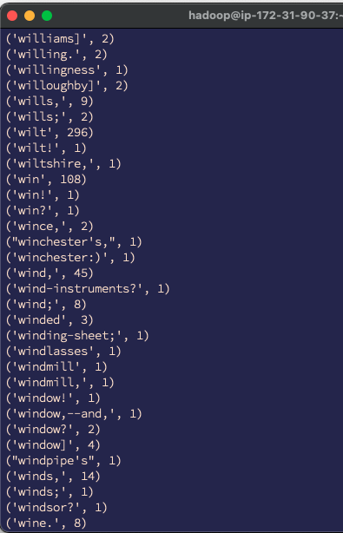

**Lab report screen-shot #18:**

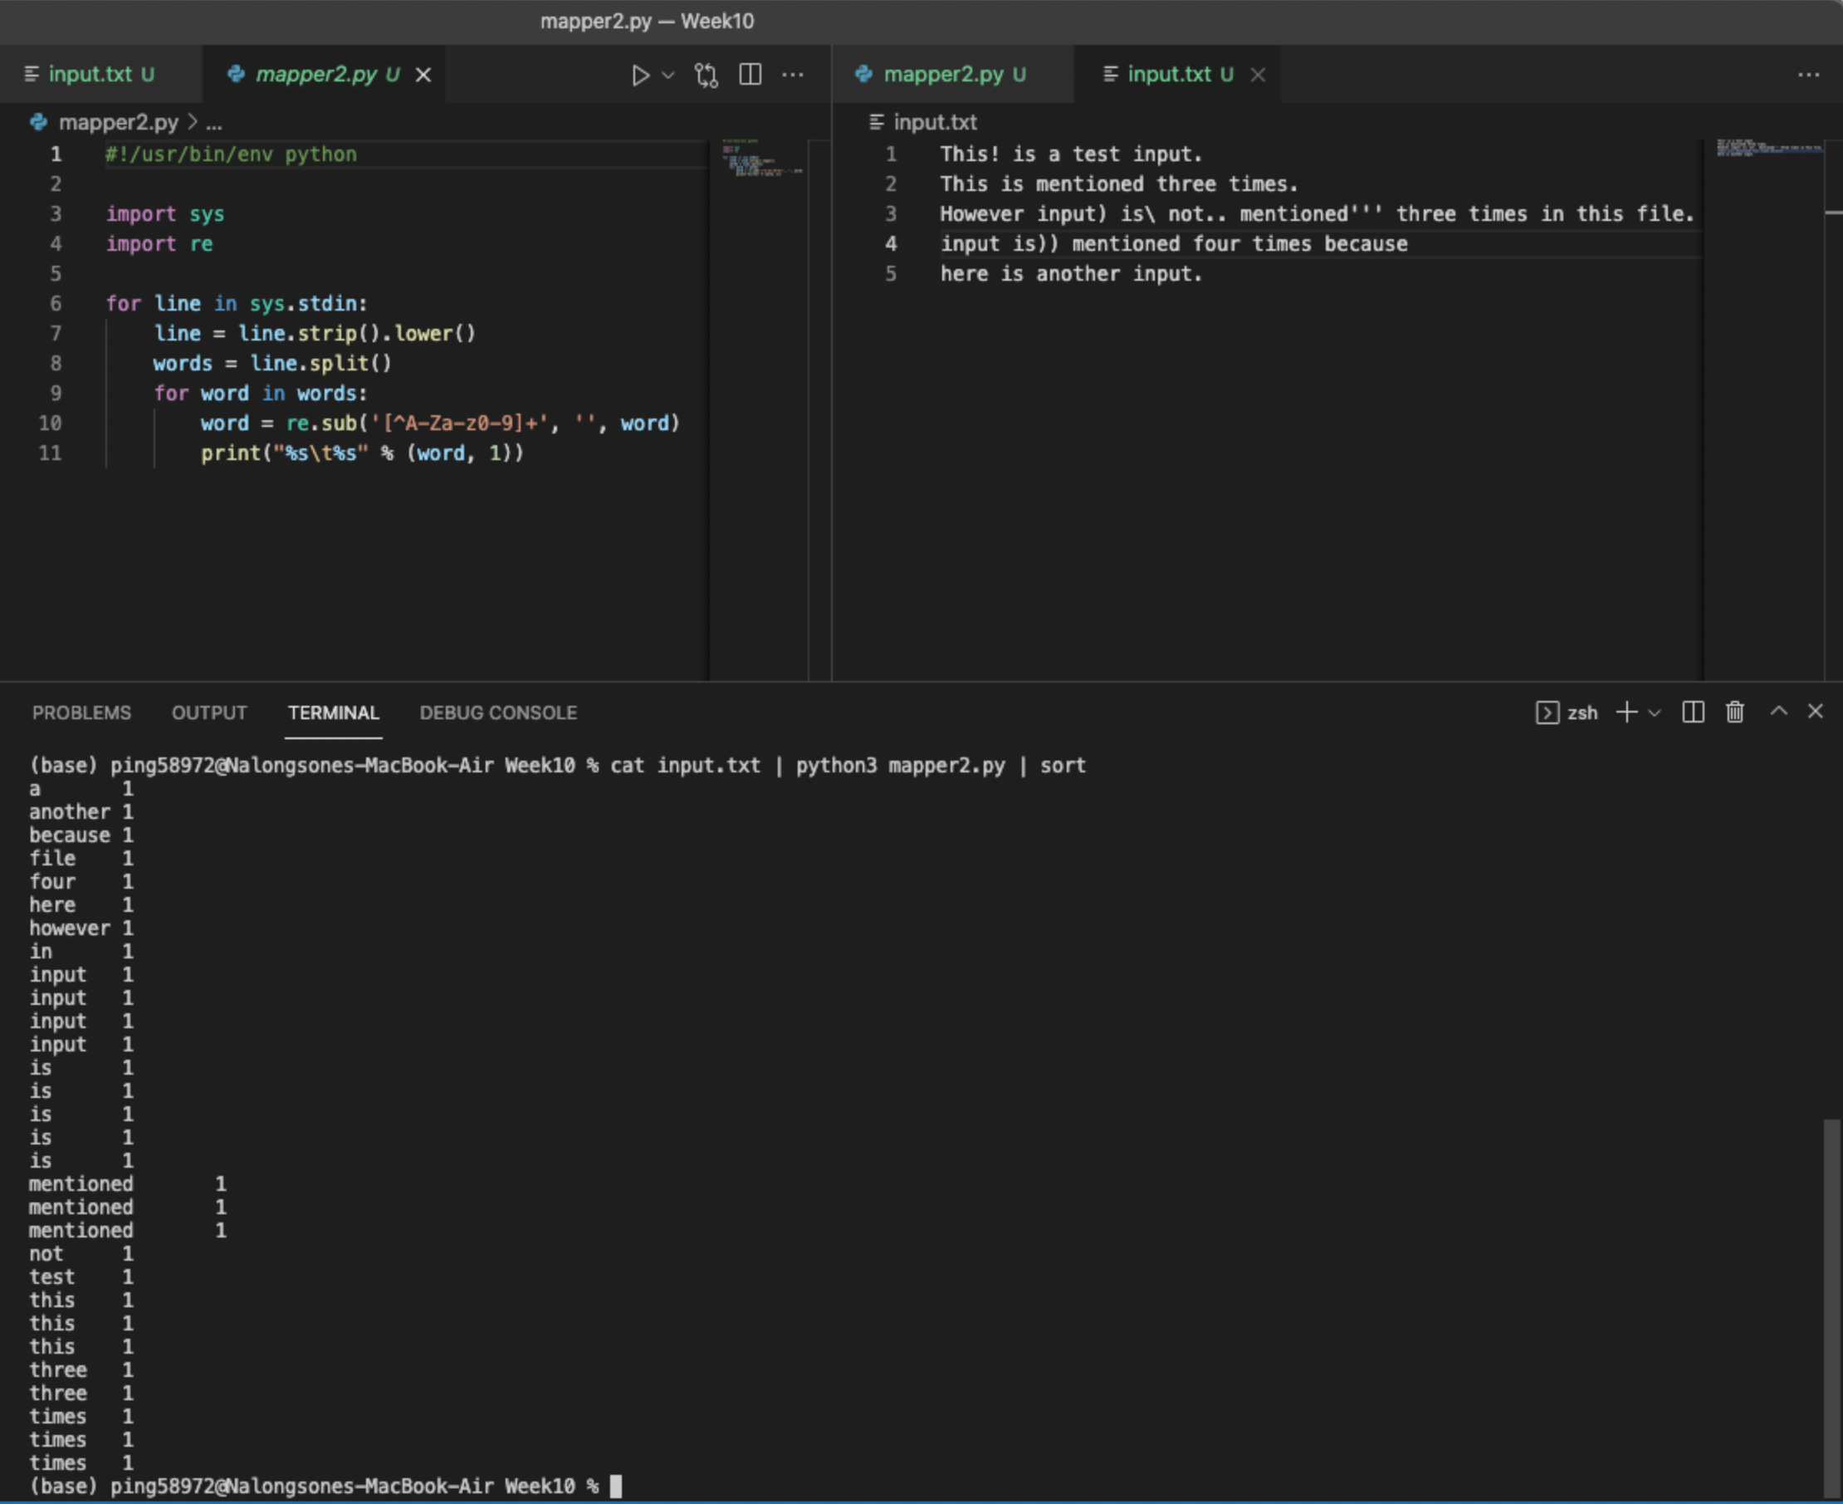

**Lab report screen-shot #19:**

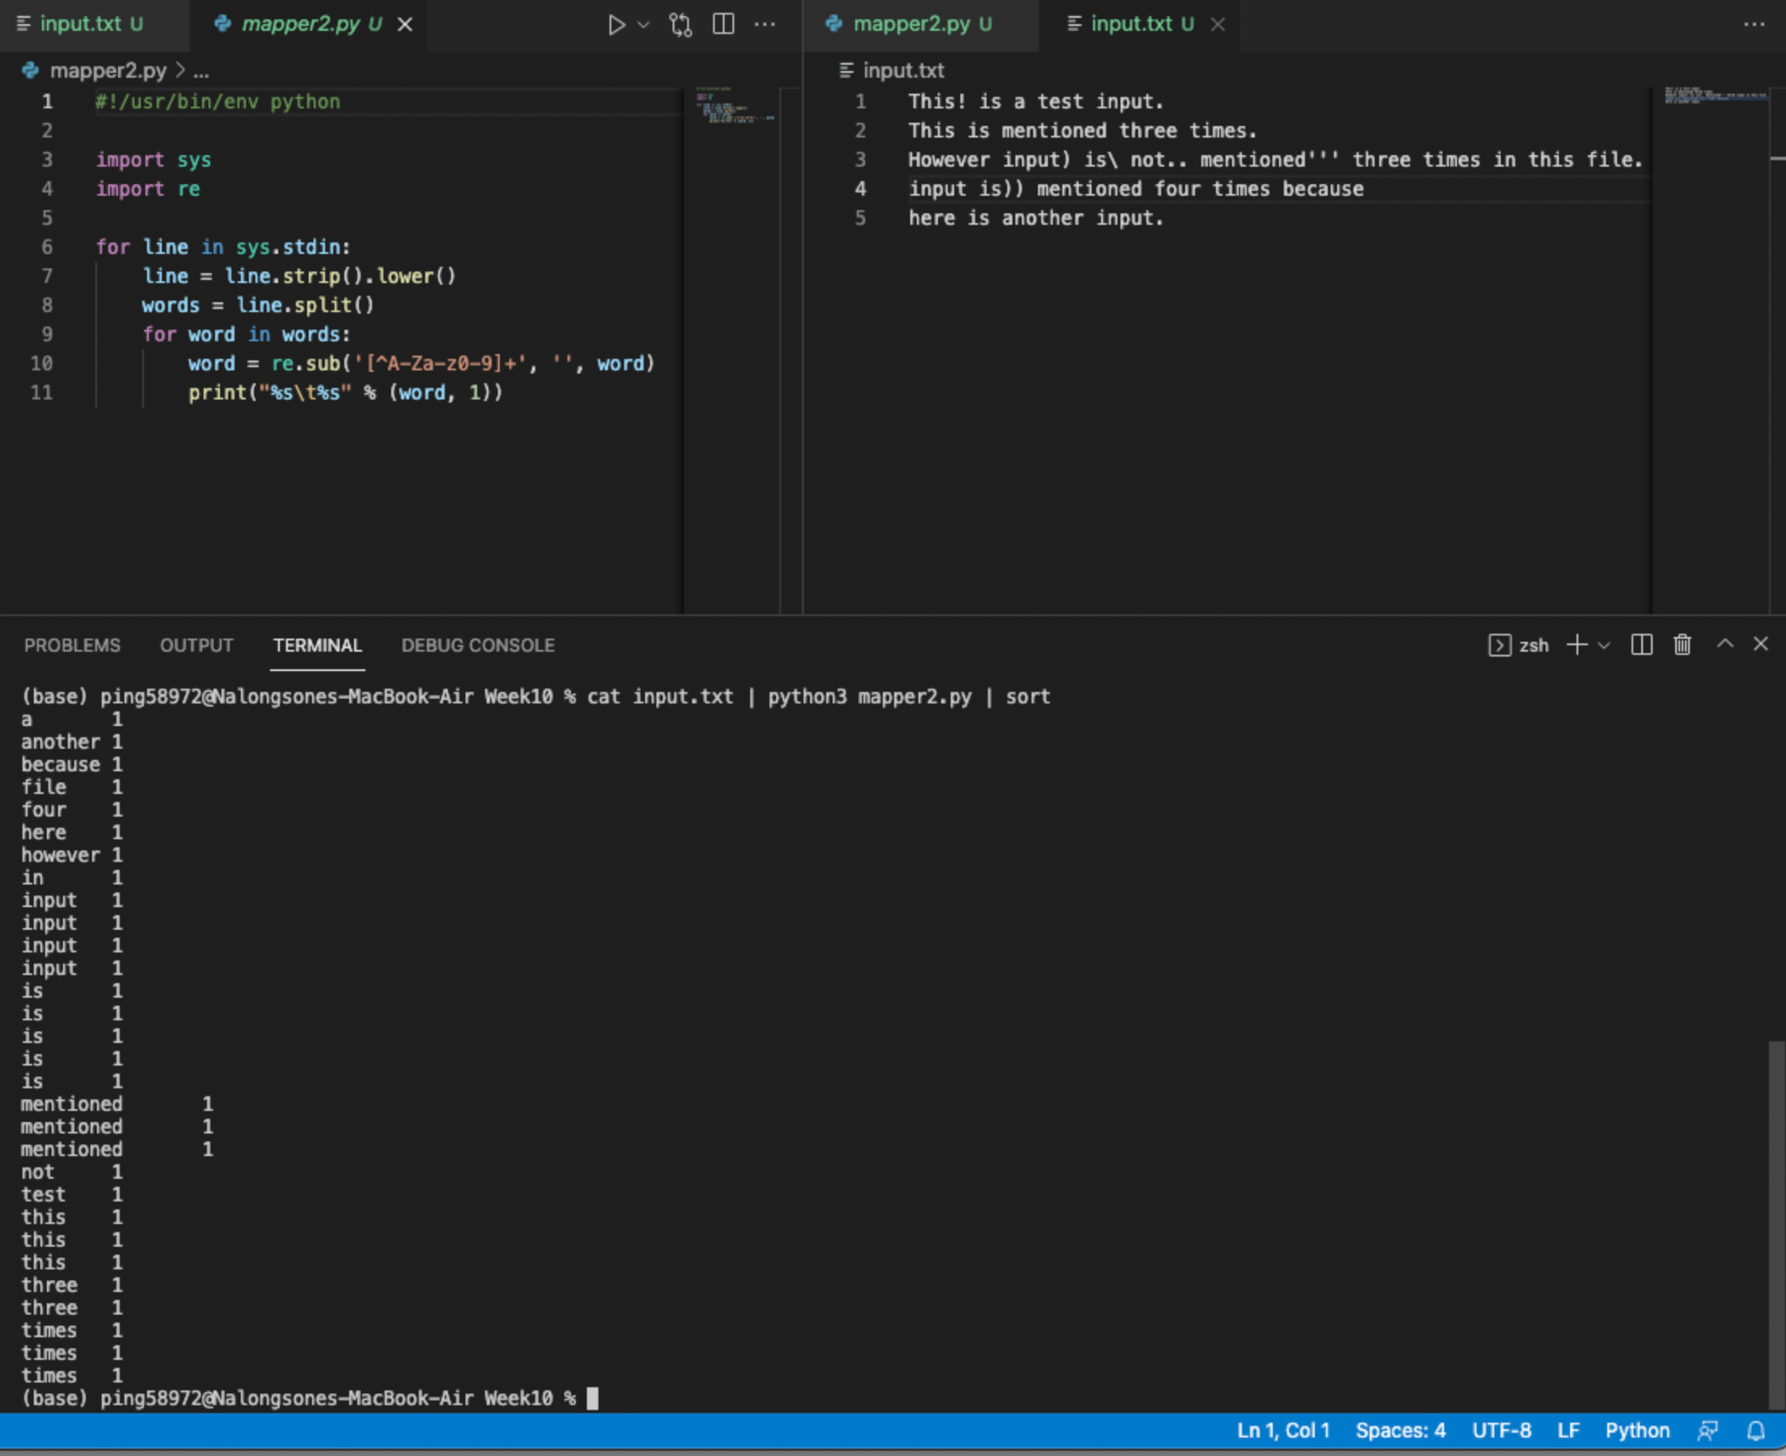

**Lab report screen-shot #20:**

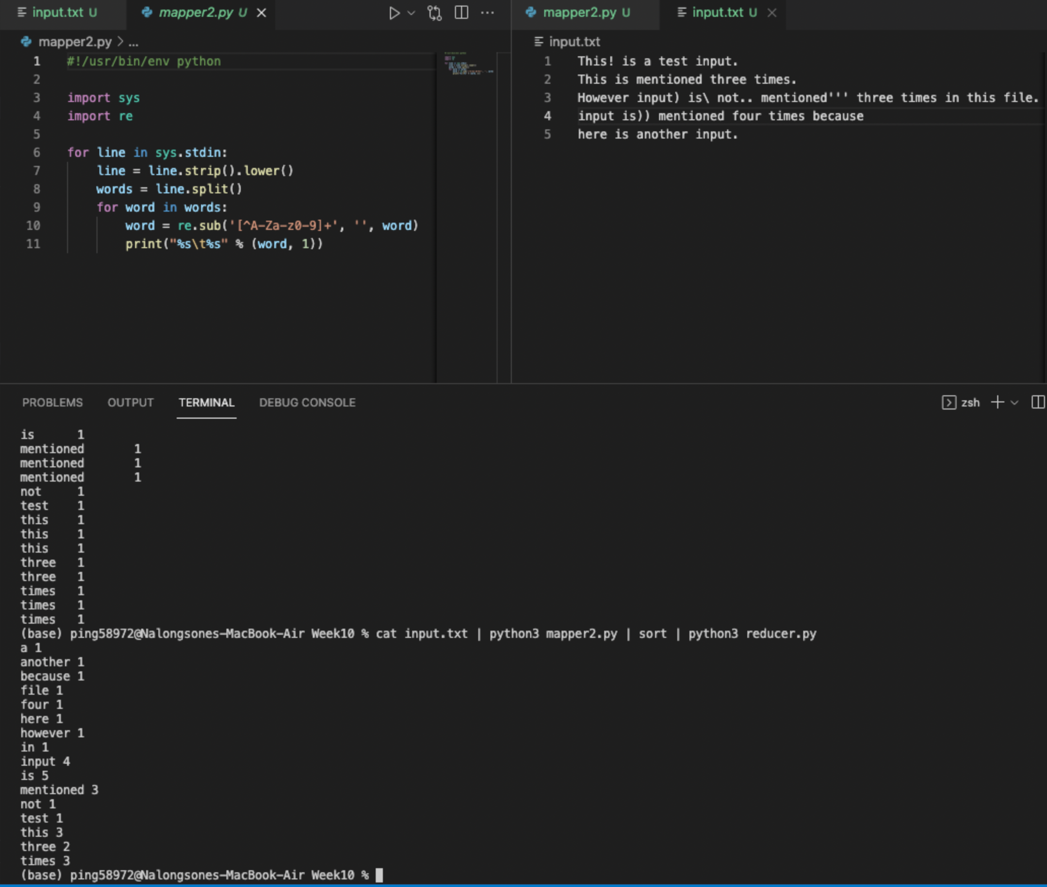

**Lab report screen-shot #21:**

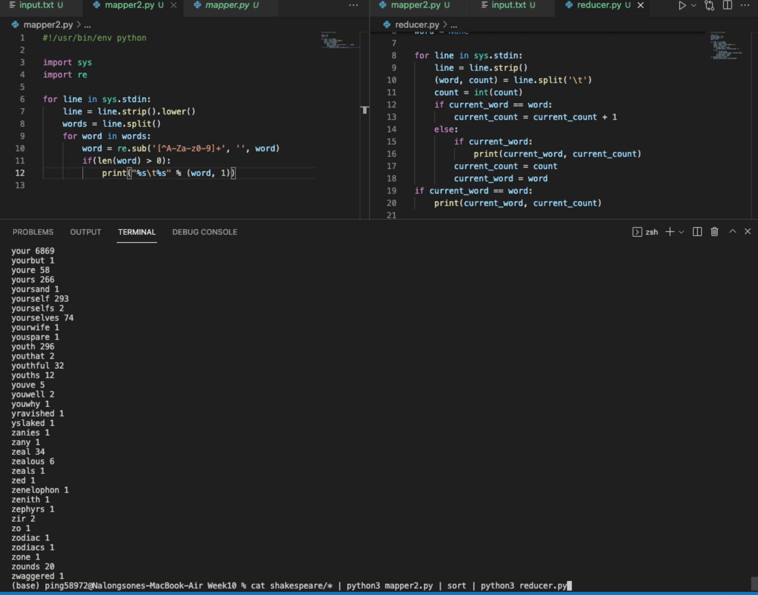

**Lab report screen-shot 22:**

|  |  |  |
| --- | --- | --- |
|  | **mapper.py** | **mapper2.py** |
| **How many data-local map tasks were executed?** | **4** | **6** |
| How many rack-local map tasks were executed? | **6** | **4** |
| How many reduce tasks? | **3** | **3** |
| Total time spent by all maps? | **4296096** | **4356480** |
| Total time spent by all reduce tasks? | **9677** | **9159** |
| How many map-input records? | **173126** | **173126** |
| How many map output records? | **939236** | **938573** |
| How many reduce input groups? | **62933** | **28941** |

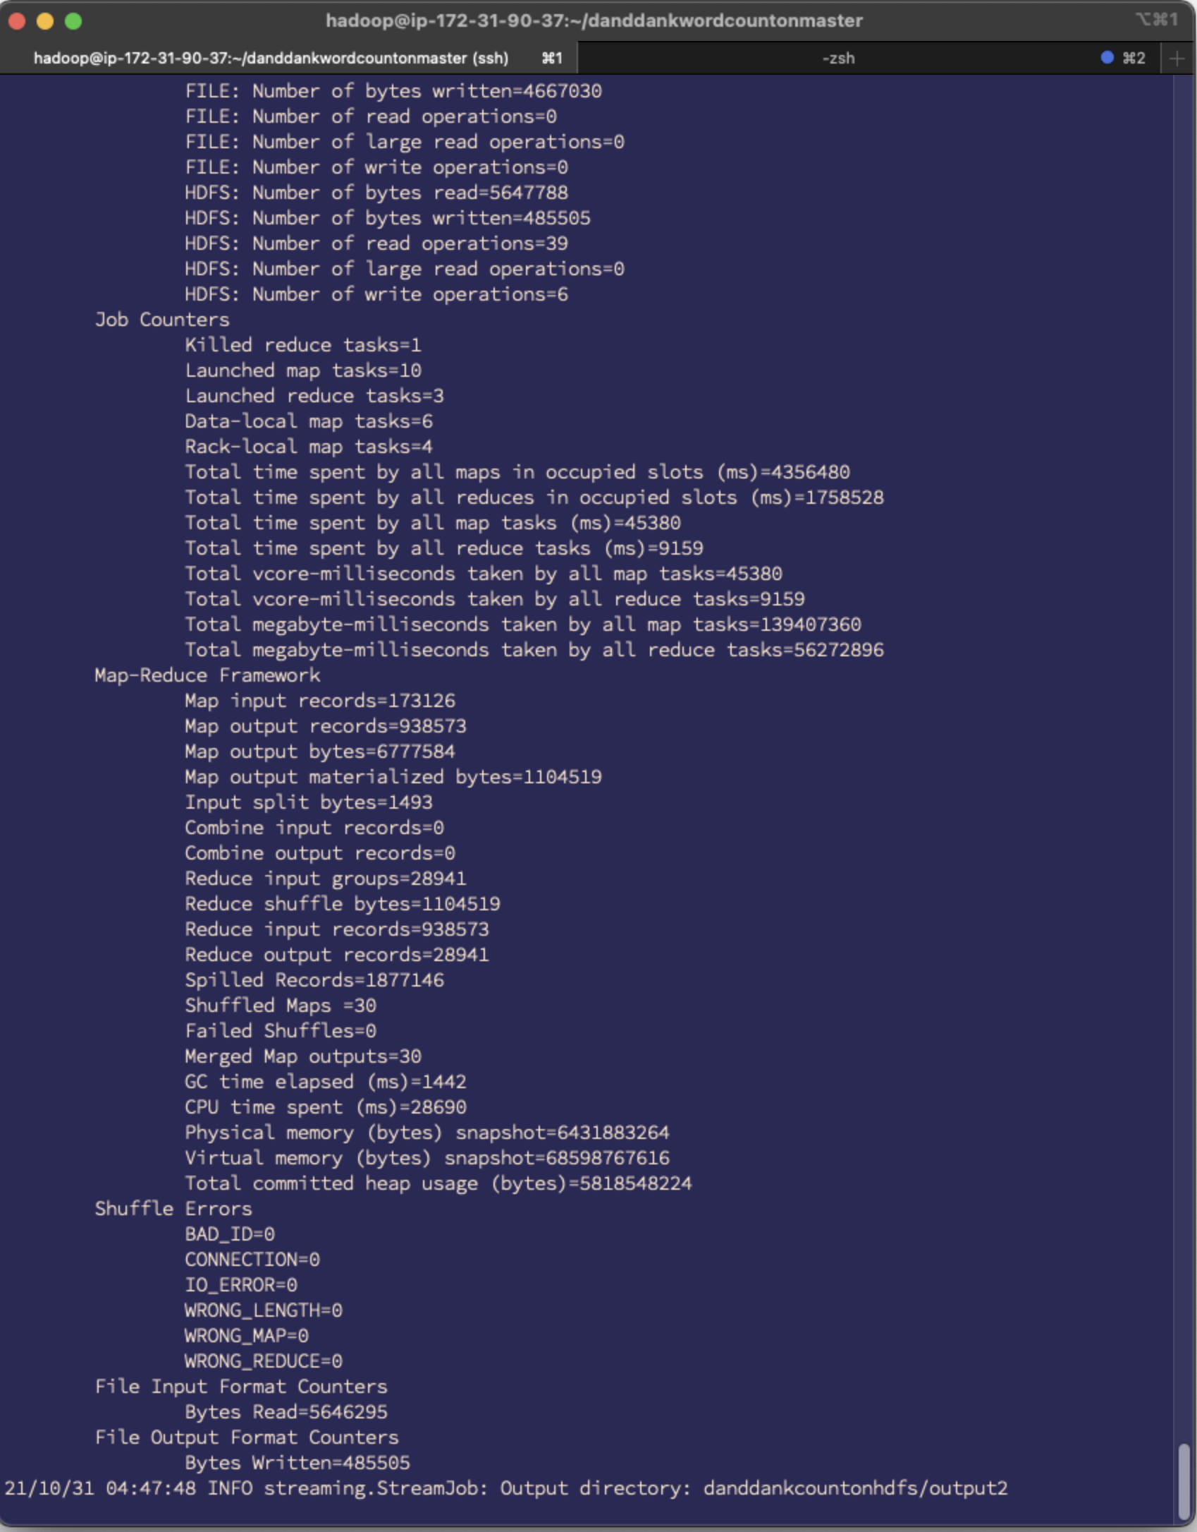

**Lab report screen-shot #23:**

